Annual Chartism Day Conference, 2022

In Honour of Professor Malcolm Chase

Saturday, 19 March 2022.
University of Leeds

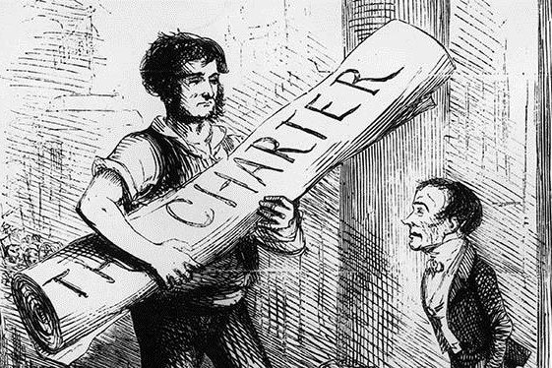

Programme
9.00–9.30 Registration

9.30–9.40 Welcome (Simon Hall, Leeds University)

9.40–9.50 Introduction and (Joan Allen and Richard C. Allen)

9.50–10.30 Richard C. Allen (Newcastle University / The Australian National University). ’Some Ungodly Immoral Principle in the Human Heart’: Exploring Opposition to Physical Force Chartism in Wales, 1839 (Chair: Joan Allen)

10.30–10.45 Janette Martin (John Rylands, Manchester). A Chartist Life (1): Samuel Collins
(1802–1878)

10.45–11.15 Break

11.15–12.00 Mike Sanders (University of Manchester). From ‘Ludding Time’ to ‘The Welsh Patriots’: John Stafford and the Construction of a Radical Tradition Through Song. (Chair: Richard C. Allen)

12.00–12.15 Jennifer Reid. Chartist Songs from Stafford

12.15–13.00 Joan Allen (Newcastle University). Trials and Tribulations: Political Identity, Class and Status in the Age of the Chartists, 1839–1843. (Chair: tbc)

13.00–13.15 Mark Crail, (SSLH / Chartist Ancestors). A Chartist Life (2): James Grassby (1807–18??)

13.15–14.15 Lunch

14.15–14.25 Henry Irving (Social History Society)

14.25–15.10 Vic Clarke (University of York). The ‘Northern’ Star? From Leeds General Advertiser to National Trades’ Journal, 1843–1845. (Chair: tbc)

15.10–15.25 David Osmond (Independent Scholar). A Chartist Life (3): William Edwards
(1796–1849)
15.25–15.55 Break

15.55–16.40 Matt Roberts (Sheffield Hallam University). ‘Ever Present to the Progressive Mind: Heritage Politics and the Memory of Chartism in England and Wales, 1918–2020. (Chair:tbc)

16.40–16.50 Shirley Chase

End of Conference

Sponsors: with grateful thanks to the School of History, University of Leeds; Social History Society; and The Society for the Study of Labour History

